**Counter using java request in JMeter:**

Test plan-right click-Threads-thread groups

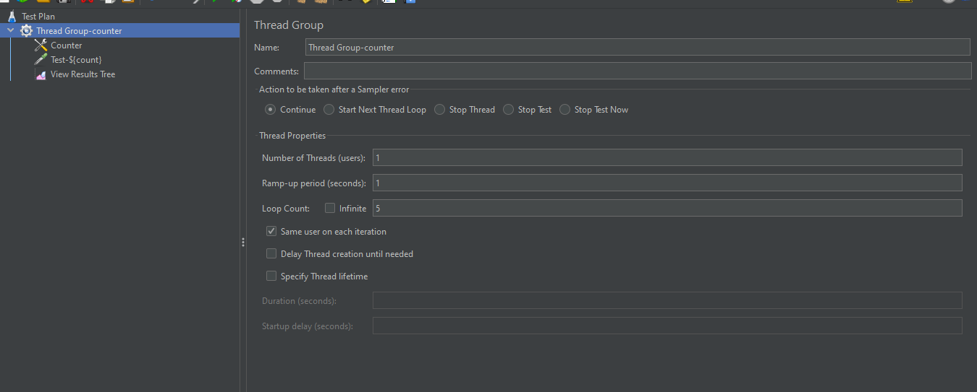

Thread group-add-config element-counter

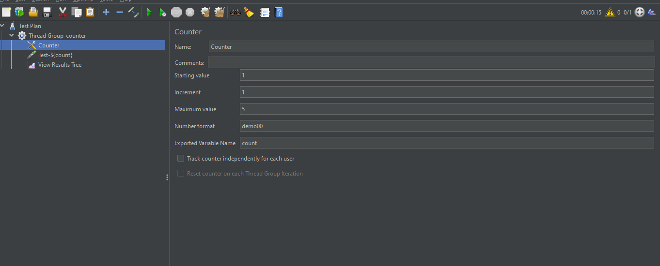

Thread group-add-sampler-java request.

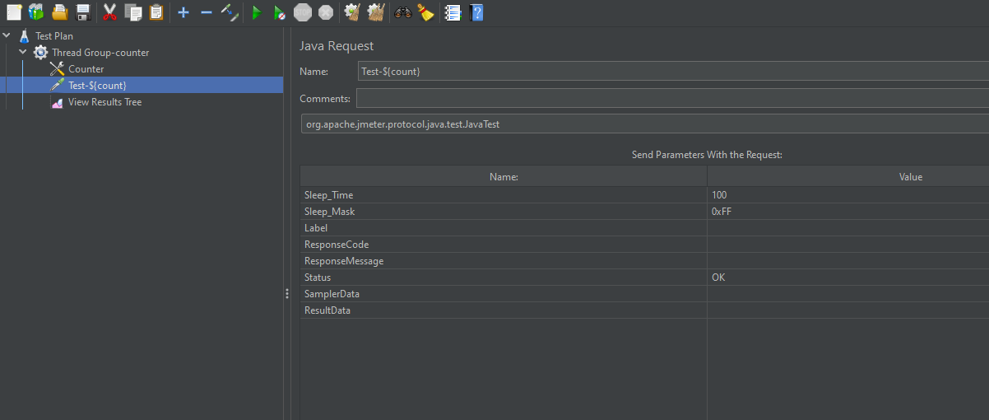

If we run it the tests executed in order up to the limit.

